Application Onboarding Guide –

End-to-End Integration Options

Version History
Version | Date | Author | Description
0.1 | Jan 2026 | Akhil Sangam | Initial Version
Note: The Annexures will be validated and cleaned up, as required prior to deployment

Reference Documents
ID | Document

Contents
1. Purpose 4
2. Integration Decision Flow (Recommended Order) 4
3. Out-of-the-Box (OOTB) Connectors – Preferred Option 4
3.1 Description 4
3.2 Examples 4
3.3 Prerequisites from Application Team 4
3.4 When to Use 5
4. Web Services Integration (REST / SOAP APIs) 5
4.1 When Is This Used? 5
4.2 Supported API Types 5
4.3 Mandatory API Capabilities 5
4.4 Authentication & Security Requirements 6
4.5 Prerequisites from Application Team 6
5. JDBC Integration (Direct Database Connectivity) 6
5.1 When Is This Used? 6
5.2 Supported Use Cases 6
5.3 Prerequisites from Application & DB Teams 6
5.4 Security Considerations 7
6. Delimited File Integration (CSV / Flat Files) 7
6.1 When Is This Used? 7
6.2 Supported Use Cases 7
6.3 Prerequisites from Application Team 7
6.4 Limitations 7
7. Common Prerequisites (Applicable to All Integrations) 8
7.1 IdentityIQ Requirements 8
7.2 Environment & Connectivity 8
8. Information Required from Application Teams (Checklist) 8
9. Onboarding Lifecycle in IdentityIQ 8
10. Summary 9
11. RACI Matrix (Roles & Responsibilities) 9
12. Integration Decision Flow 10
12.1 Visual Flow Diagram (Integration Selection) 10
12.2 Textual Decision Flow (Reference) 10
13. Provisioning Capability Matrix 10
14. Sample REST API Payloads (Illustrative) 11
Create Account (REST) 11
Disable Account (REST) 11
15. Sample JDBC Queries (Illustrative) 11
Account Aggregation 11
Disable Account 11
16. File-Based Integration Example 11
Sample CSV Format 11
File Handling Expectations 12
17. End-to-End Onboarding Checklist (A–Z) 12
18. Governance, Risk & Compliance Alignment 12
18.1 Security & Compliance Controls 12
18.2 Audit & Certification Readiness 12
19. Non-Functional Requirements (Enterprise Scale) 13
19.1 Performance & Scalability 13
19.2 Availability & Resilience 13
20. Environments & Release Management 13
Release Expectations 13
21. SLA & Support Model 13
22. Common Risks & Mitigations 13
23. Architecture Reference (Textual) 14
Logical View 14
Data Flow 14
24. Executive Summary (For Leadership) 14
25. Contact & Support 14

1. Purpose
This document serves as a comprehensive application onboarding guide for SailPoint IdentityIQ (IIQ). It is intended for application owners, developers, database teams, and infrastructure teams involved in integrating applications with IdentityIQ.
The goal of this document is to provide end-to-end guidance for application onboarding into SailPoint IdentityIQ (IIQ). It outlines:
- All supported application integration options available in SailPoint IdentityIQ
- The decision hierarchy and selection criteria for choosing the appropriate integration method
- Prerequisites, technical requirements, and dependencies for each integration type
- Roles, responsibilities, and expectations from application teams during the onboarding process

2. Integration Decision Flow (Recommended Order)
SailPoint IdentityIQ supports multiple integration approaches. The recommended order of evaluation is:
- Out-of-the-Box (OOTB) Connector – Preferred
- Web Services (REST / SOAP APIs)
- JDBC (Direct Database Integration)
- Delimited Files (CSV / Flat Files) – Last resort
The most secure, scalable, and real-time option available should always be selected.

3. Data Flow (High-Level)
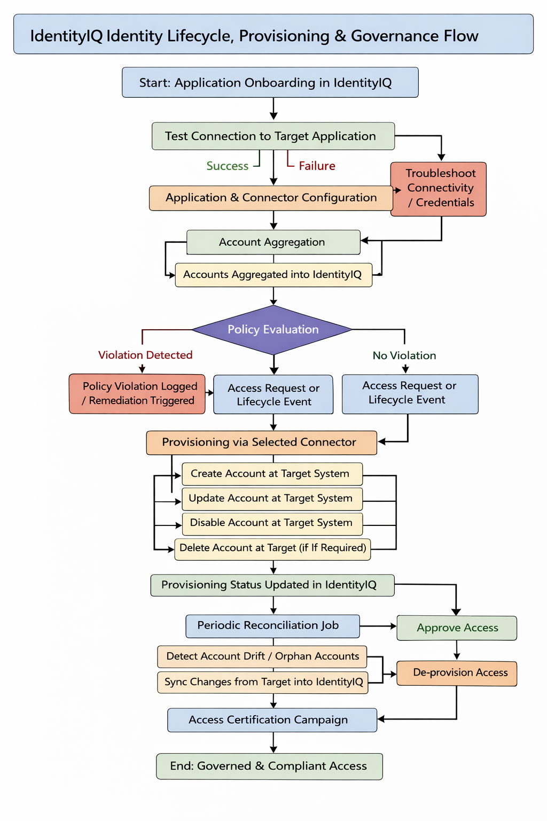
- SailPoint IdentityIQ provides centralized identity governance by managing the complete lifecycle of identities and their access across connected applications.
- The process begins with onboarding the target application into IdentityIQ, where the appropriate connector is configured. A connection test is performed to validate connectivity, authentication, and technical readiness. Any connectivity or credential issues are resolved prior to proceeding.
- Once the connection is successfully established, IdentityIQ performs account aggregation to retrieve existing accounts from the target system. Aggregated accounts are correlated to existing identities or used to create new identities within IdentityIQ, ensuring accurate representation of user access.
- Following aggregation, IdentityIQ evaluates identities and associated accounts against defined governance policies, including segregation of duties (SoD) and access compliance rules. Policy violations are logged and remediation workflows may be initiated in accordance with organizational controls.
- Access changes are initiated through user lifecycle events (joiner, mover, leaver) or formal access requests. Based on these events, IdentityIQ executes provisioning actions via the configured connector to create, update, disable, or delete accounts on the target system as required. Provisioning outcomes are recorded to maintain audit traceability.
- IdentityIQ performs periodic reconciliation to detect discrepancies between the target system and IdentityIQ records. This process identifies account drift and orphaned accounts and synchronizes changes to maintain data integrity.
- In addition, scheduled access certification campaigns are conducted, during which managers or application owners review and attest to user access. Approved access is retained, while revoked access triggers automated de-provisioning, ensuring enforcement of least-privilege principles.
- Through continuous aggregation, reconciliation, policy enforcement, and certification, IdentityIQ ensures that access remains governed, compliant, and auditable throughout the identity lifecycle.

4. Out-of-the-Box (OOTB) Connectors – Preferred Option

4.1. Description
Out-of-the-Box (OOTB) connectors are pre-built, SailPoint-provided integrations designed to connect IdentityIQ with widely used enterprise applications and platforms. They are delivered as part of the product and follow SailPoint’s standard integration framework, which significantly reduces implementation effort and risk.
Key Characteristics of OOTB Connectors
- Minimal or no custom development
Configuration is primarily metadata-driven (UI-based or XML), avoiding custom rules or scripts in most cases.
- Vendor-supported and upgrade-safe
These connectors are fully supported by SailPoint and are tested against specific application versions. Enhancements and fixes are typically included in product upgrades.
- Standardized capabilities
Most OOTB connectors support:
  - Account aggregation
  - Entitlement aggregation
  - Provisioning (create, update, disable, delete etc.)
  - Password management (where supported by target system)
  - Group/role membership management
- Predefined schemas and operations
Attribute mappings, account schemas, and provisioning operations are already defined based on the target system’s APIs or protocols.
- Security and compliance aligned
Supports secure authentication mechanisms such as OAuth2, certificates, service accounts, and encrypted credentials, aligned with SailPoint best practices.
Note: Refer to Section “Direct Connector List” under Annexure for the list of Direct Connectors available in SailPoint.

4.2. Prerequisites from Application Team
- Application version compatibility confirmation
- Service account credentials
- Network connectivity between IdentityIQ and target system
- Required privileges for provisioning and aggregation

4.3. When to Use
- OOTB connector is available and supported
- No customization beyond standard use cases

5. Web Services Integration (REST / SOAP APIs)

5.1. When Is This Used?
Used when:
- No suitable OOTB connector exists
- Application exposes APIs
- Near real-time or real-time provisioning is required.

5.2. Supported API Types
- REST APIs (Preferred)
- SOAP APIs (Supported)

5.3. Mandatory API Capabilities

Account Lifecycle APIs
Operation | Description
Create Account | Create a user account
Update Account | Modify user attributes
Disable Account | Deactivate/suspend account
Enable Account | Reactivate account
Delete Account (Optional) | Delete account if allowed
Account Aggregation | Retrieve all accounts
Single Account Aggregation | Retrieve single account
Lock Account | Lock User Account
Unlock Account | Unlock User Account

Entitlement APIs (If Applicable)
Operation | Description
Add Entitlement | Assign role/group
Remove Entitlement | Revoke role/group

5.4. Authentication & Security Requirements
- Basic Authentication
- API Token Authentication
- OAuth 2.0 Authentication
- Custom Authentication

5.5. Prerequisites
- API documentation
- Test environment access
- Sample request/response payloads
- Error codes and retry behavior
- Rate limits or throttling constraint

5.6. Required Permissions
The user /administrator must have the required permissions to call the web services API of the managed system.

5.7. Sample Payloads
Account Aggregation
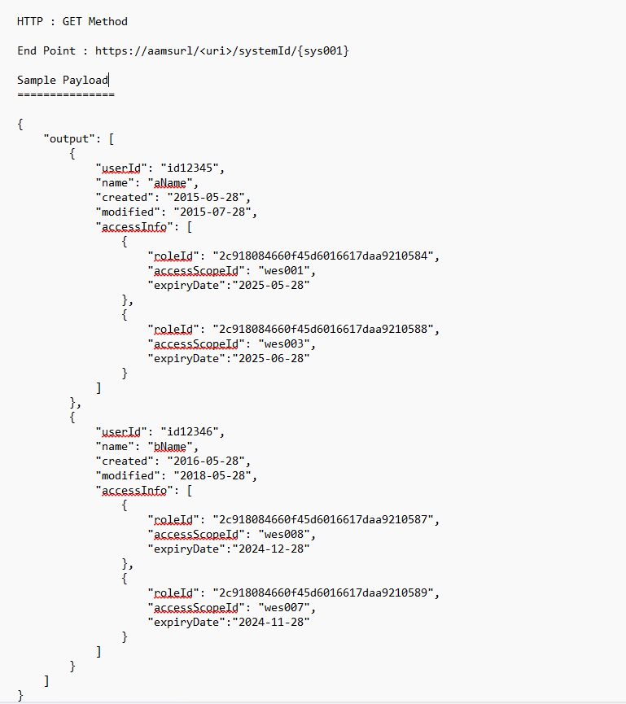

Single Account Aggregation

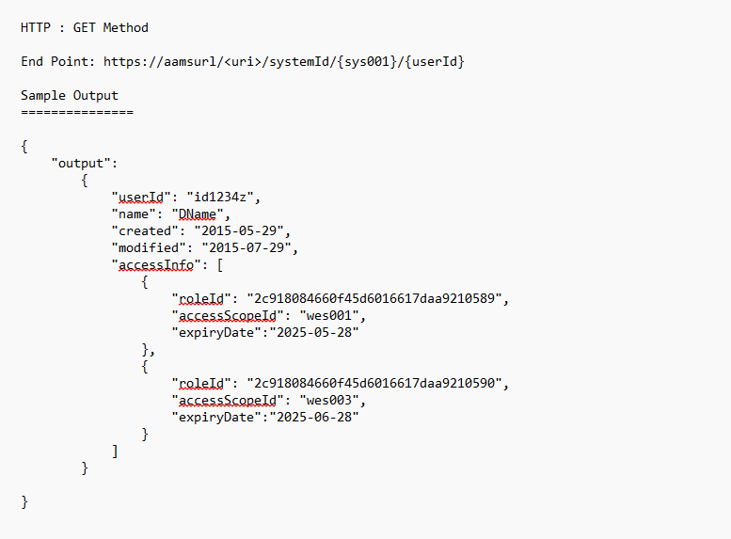

Add Entilement:

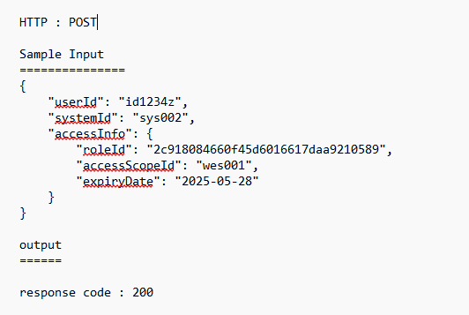

Remove Entitlement:

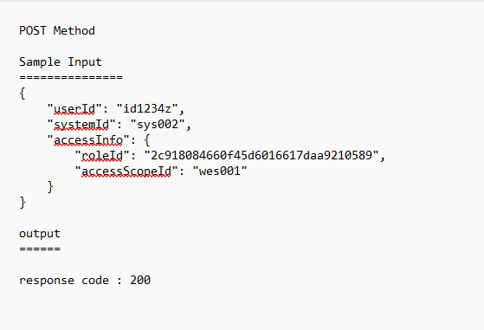

Create Account
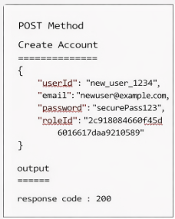
Enable Account

Disable Account

Unlock Account

Lock Account

6. JDBC Integration (Direct Database Connectivity)

6.1. When Is This Used?
Used when: -
- Application does not expose APIs
- Database access is allowed
- Data model is stable and well-understood

6.2. Supported Use Cases
- Account aggregation
- Entitlement aggregation
- Provisioning (Insert/Update/Delete/Disable/Enable etc.)
- Provisioning via JDBC is supported but should be carefully governed.

6.3. Prerequisites
- Database type and version (Oracle, SQL Server, MySQL, etc.)
- JDBC driver availability
- Database hostname, port, and SID/service name
- Read/write service account
- Approved SQL queries for aggregation/provisioning
- Firewall/network connectivity

5.4. Security Considerations
- Read-only access preferred for aggregation
- Audit logging at database level
- No hard-coded credentials

5.5. Sample Queries
Operation | Purpose | Sample SQL Query | Notes
Get All Accounts | Retrieve all accounts for aggregation into IdentityIQ | SELECT USER_ID, USERNAME, EMAIL, STATUS, CREATED_DATE, LAST_UPDATED_DATE FROM USER_ACCOUNTS; | Used during full or incremental account aggregation
Create Account | Provision a new account in the target system | INSERT INTO USER_ACCOUNTS ( USER_ID, USERNAME, EMAIL, STATUS, CREATED_DATE ) VALUES ( :USER_ID, :USERNAME, :EMAIL, 'ACTIVE', CURRENT_TIMESTAMP ); | Parameters are dynamically passed from IAM
Disable Account | Revoke user access while retaining the account record | UPDATE USER_ACCOUNTS SET STATUS = 'DISABLED', LAST_UPDATED_DATE = CURRENT_TIMESTAMP WHERE USER_ID = :USER_ID; | Recommended over delete for audit purposes
Disable Account (Flag-Based) | Disable account using enable/disable flag | UPDATE USER_ACCOUNTS SET ENABLED_FLAG = 'N' WHERE USER_ID = :USER_ID; | Applicable where status field is not available
Enable Account | Restore previously disabled user access | UPDATE USER_ACCOUNTS SET STATUS = 'ACTIVE', LAST_UPDATED_DATE = CURRENT_TIMESTAMP WHERE USER_ID = :USER_ID; | Used for rehire or access reinstatement
Update Account | Modify account attributes (e.g., username, email) | UPDATE USER_ACCOUNTS SET EMAIL = :EMAIL, USERNAME = :USERNAME, LAST_UPDATED_DATE = CURRENT_TIMESTAMP WHERE USER_ID = :USER_ID; | Used during attribute changes
Delete Account | Permanently remove account from target system | DELETE FROM USER_ACCOUNTS WHERE USER_ID = :USER_ID; | Use only if required by target system
Soft Delete Account | Logically delete account while preserving audit trail | UPDATE USER_ACCOUNTS SET STATUS = 'DELETED' WHERE USER_ID = :USER_ID; | Preferred approach for compliance

6. Delimited File Integration (CSV / Flat Files)

6.1 When Is This Used?
Used when: -
- No APIs or database access is available
- Application is legacy or external
- Batch-based processing is acceptable

6.2 Supported Use Cases
- Account aggregation
- Entitlement aggregation
- Manual or semi-automated provisioning

6.3 Prerequisites from Application Team
- File format definition (CSV, pipe-delimited, etc.)
- Attribute-to-column mapping
- File naming conventions
- File delivery method (SFTP, shared folder)
- File frequency and schedule

6.4 Limitations
- No real-time provisioning
- Higher operational overhead
- Increased reconciliation effort

6.5 Sample CSV Format
user_id,first_name,last_name,email,status
jsmith,John,Smith,john.smith@example.com,ACTIVE
File Handling Expectations
- UTF-8 encoding
- Header row mandatory
- Consistent delimiter
- Atomic file drops (no partial files)

7. Common Prerequisites (Applicable to All Integrations)

7.1 IdentityIQ Requirements
- Application owner assigned
- Source/Target application classification
- Account and entitlement schema defined
- Correlation rules agreed
- Provisioning policies approved

7.2 Environment & Connectivity
- Network firewall rules
- DNS resolution
- Non-production and production endpoints
- Change and release coordination

8. Information Required from Application Teams (Checklist)
- Integration method selected (OOTB / API / JDBC / File)
- Application documentation
- Attribute list and definitions
- Account lifecycle rules
- Entitlement model
- Test accounts
- Contact points for testing and support

9. Onboarding Lifecycle in IdentityIQ
- Application intake and assessment
- Integration method selection
- Connector/configuration development
- Aggregation testing
- Provisioning testing
- Certification readiness
- Go-live and monitoring

10. Summary
This document ensures that any application team—regardless of technical maturity—can understand how their system can integrate with SailPoint IdentityIQ and what is required at each step.

11. RACI Matrix (Roles & Responsibilities)
R = Responsible, A = Accountable, C = Consulted
Activity | Application Team | IAM / IdentityIQ Team | Infrastructure / DB Team
Application assessment | R | A | C
Integration method decision | C | A | C
API / DB / File readiness | R | C | R
Connector configuration | C | A | C
Aggregation testing | C | A | C
Provisioning testing | C | A | C
Go-live approval | A | R | C
Post go-live support | C | R | C

12. Integration Decision Flow

12.1 Visual Flow Diagram (Integration Selection)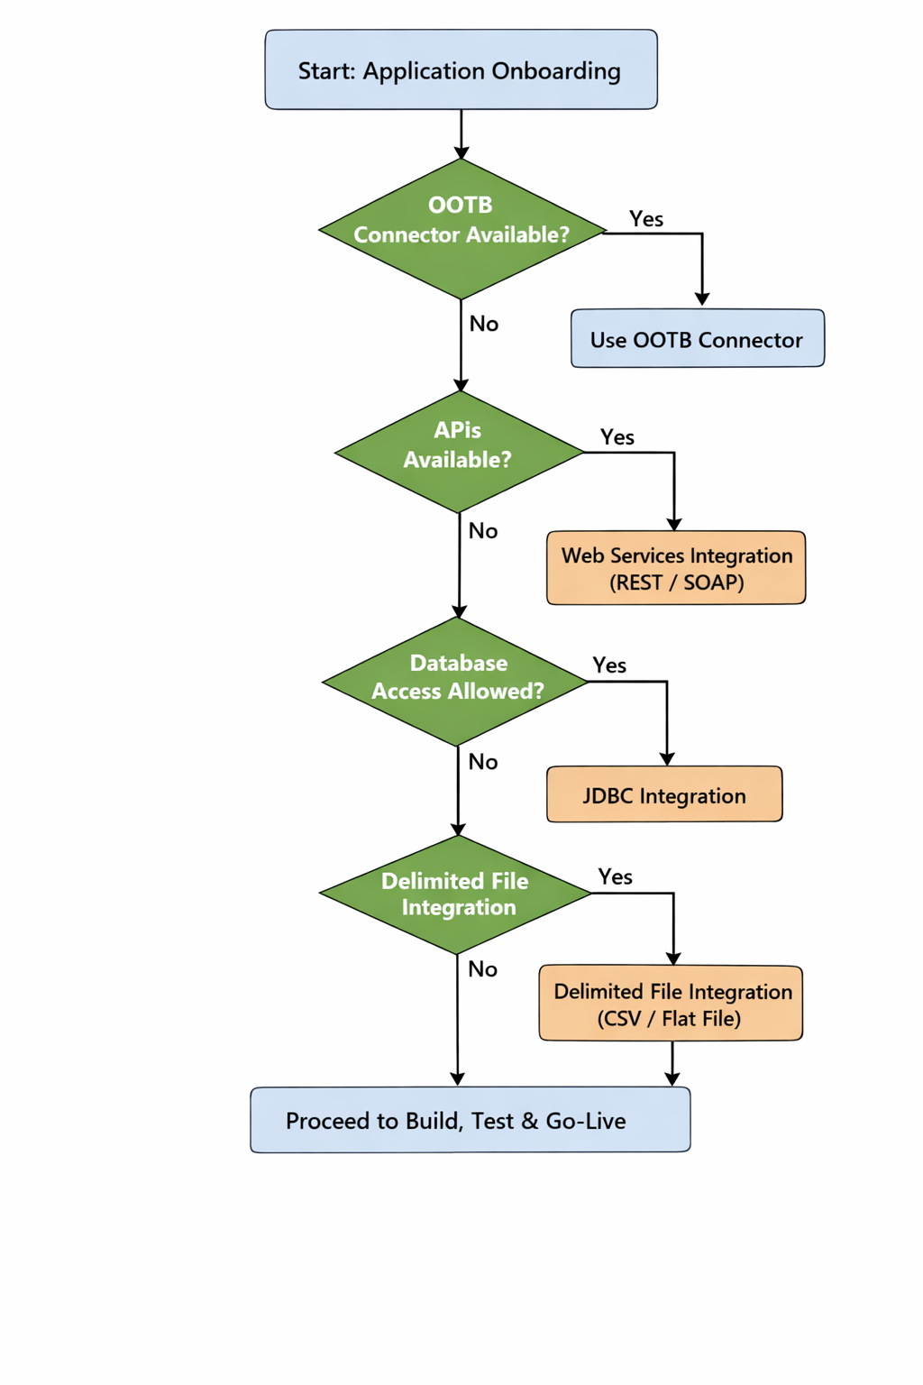

12.2. Textual Decision Flow (Reference)
- Check if an OOTB connector exists and is supported
- If yes → use OOTB connector
- If no → proceed to API evaluation
- Check if the application exposes REST or SOAP APIs
- If yes → use Web Services connector
- If no → proceed to JDBC evaluation
- Check if direct database access is permitted and supported
- If yes → use JDBC connector
- If no → proceed to file-based integration
- Use Delimited File (CSV) integration as the last option

13. Provisioning Capability Matrix
Capability | OOTB | API (Web Services) | JDBC | Delimited File
Account Create | Yes | Yes | Yes* | Limited
Account Update | Yes | Yes | Yes* | Limited
Account Disable | Yes | Yes | Yes* | No
Account Delete | Optional | Optional | Optional | No
Entitlement Assignment | Yes | Yes | Limited | No
Near Real-Time | Yes | Yes | No | No
Certification Ready | Yes | Yes | Yes | Yes

Note: Depends on database permissions and governance approval

14. End-to-End Onboarding Checklist (High Level)
- Application owner identified
- Integration option selected
- Attribute & entitlement model finalized
- Connectivity approved
- Service accounts created
- Test data provided
- Aggregation validated
- Provisioning validated
- Certification readiness confirmed
- Go-live approval obtained

15. Governance, Risk & Compliance Alignment

15.1 Security & Compliance Controls
All integrations with SailPoint IdentityIQ must comply with organizational security standards.
Control Area | Enterprise Expectation
Authentication | Service accounts only, no personal IDs
Authorization | Least-privilege access
Encryption | TLS 1.2+ for data in transit
Credential Storage | Encrypted vault / IIQ secure storage
Logging & Audit | Provisioning and aggregation logs retained
Segregation of Duties | App admin ≠ IAM admin

15.2 Audit & Certification Readiness
The integration must support:
- Periodic account and entitlement aggregation
- IdentityIQ access certifications
- Joiner/Mover/Leaver lifecycle enforcement
- Evidence generation for auditors

16. Non-Functional Requirements (Enterprise Scale)

16.1 Performance & Scalability
- Support bulk aggregation without timeouts
- Pagination support for APIs
- Throttling awareness
- Parallel processing where applicable

16.2 Availability & Resilience
- Defined maintenance windows
- Retry and error-handling mechanisms
- Idempotent provisioning APIs (where possible)

17. Environments & Release Management
Environment | Purpose
Development | Initial connector development
Test / QA | Functional and regression testing
UAT | Business validation
Production | Live operations

Release Expectations
- Change records approved
- Rollback plan defined
- Cutover communication completed

18. SLA & Support Model

Area | Responsibility | SLA Expectation
Connector availability | IAM Team | As per platform SLA
Application API uptime | App Team | As per app SLA
Incident response | Joint | Severity-based
Data issues | IAM / App | Collaborative

19. Common Risks & Mitigations
Risk | Mitigation
Missing APIs | Evaluate JDBC / File fallback
API changes | Versioning and contract management
Poor data quality | Pre-validation rules
Excessive privileges | Regular access reviews
Manual dependencies | Automation roadmap

20. Executive Summary (For Leadership)
This onboarding framework enables: -
- Consistent, secure application integrations
- Reduced manual access management
- Audit-ready identity governance
- Scalable onboarding across enterprise systems

21. Contact & Support
For questions related to SailPoint IdentityIQ onboarding, governance, or integrations, please contact the IAM / IGA implementation team.

22. References
https://documentation.sailpoint.com/identityiq/help/application_management/index.html
https://documentation.sailpoint.com/identityiq_83/help/appmgmt/whatdataisaggregated.htm?TocPath=Application%20Management%7CAggregation%7C_____2

